Dear families,
We would like to introduce you to the new Water Schools initiative that insert name of school will launch in insert date.

What is the Water Schools initiative?
Water Schools is an initiative to encourage children in Somerset to make water their drink of choice. In a Water School, water is the preferred drink for both children and school staff.
Why is Water Schools being launched?
Water is fundamental for brain function - attention, concentration and memory - therefore of key importance for children’s learning at school. Put simply water is the best drink for our bodies.
There is increasing concern around children’s dental health in Somerset, and given the reduced accessibility to dentist services, it is important we maintain good oral health. The sugars added to fizzy drinks, squashes, energy/sport drinks, milkshakes and that contained in shop-bought smoothies are the main culprit for tooth decay in children. Therefore, making water the drink of choice!
Overconsumption of sugars in children is also a concern for their future health. This will increase the risk of developing serious conditions later in life, including type 2 diabetes and heart disease.
In addition, energy and sport drinks are often high in caffeine, which can negatively impact children’s ability to concentrate at school and to sleep well at night.
How will Water Schools be run at school?
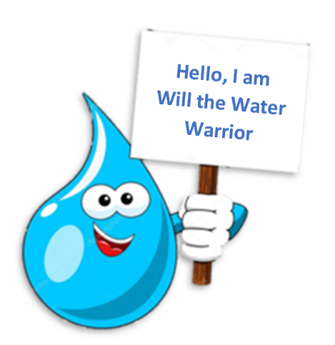
Will the Water Warrior, a friendly water drop, will be introduced to the children during school assemblies and classroom activities, with the mission to encourage more water consumption. Ideally, each child will have a clear, reusable plastic bottle they can simply refill from the tap.
Teachers and school staff will remind children of the importance of drinking water throughout the day and will encourage them to refill their bottle regularly.
Will families incur any costs?
Families are asked to provide a clear, reusable plastic bottle. In the long run, with the Water Schools initiative, families are likely to save money, as they will not need to provide drinks for their children whilst in school.
Will this be beneficial for the children?
Yes. Water will help keep children well hydrated during the day, supporting their concentration and learning at school. This may help reduce their risk of tooth decay and avoidable long-term health conditions later in life. In addition, there will be a significant reduction in the amount of single use plastic. All this contributes to a healthier and greener Somerset.

