Sheet 4: The importance of perspective in reducing conflict
To be a co-parent we need to acknowledge that our ex-partner has a perspective.
Key points
- Separation from your partner can sometimes be caused by a key difference of opinion, and those differences can be made worse when our emotions are strong. We may not trust them anymore. We may think they are incapable or useless.
- All this pushes our perspective further away from our co-parent’s, which can impact how you work together as you parent your children.
- Perspective helps you see the whole story when it comes to parenting your children – you are both their parents.
- Perspective can also help to reduce conflict between you and may help you to manage your emotions.
- Unfortunately, when emotions are high, we can become entrenched in our own perspective and unable or unwilling to take on board another viewpoint because we are trying to win and prove we are right – reinforcing the short-term mindset.
- This is about taking time to reflect on your situation and ask yourself, “How right are you?”
- Giving your ex-partner of voice maybe the last thing you want to do because it may feel like you are letting them win. BUT we are not – listening, hearing and seeing things from their perspective gives information and knowledge which will help us manage the situation.
- To be a parent, we must consciously and deliberately acknowledge that our ex-partner has a perspective as they are our children’s other parent.
Exercise: Standing in your co-parent’s shoes
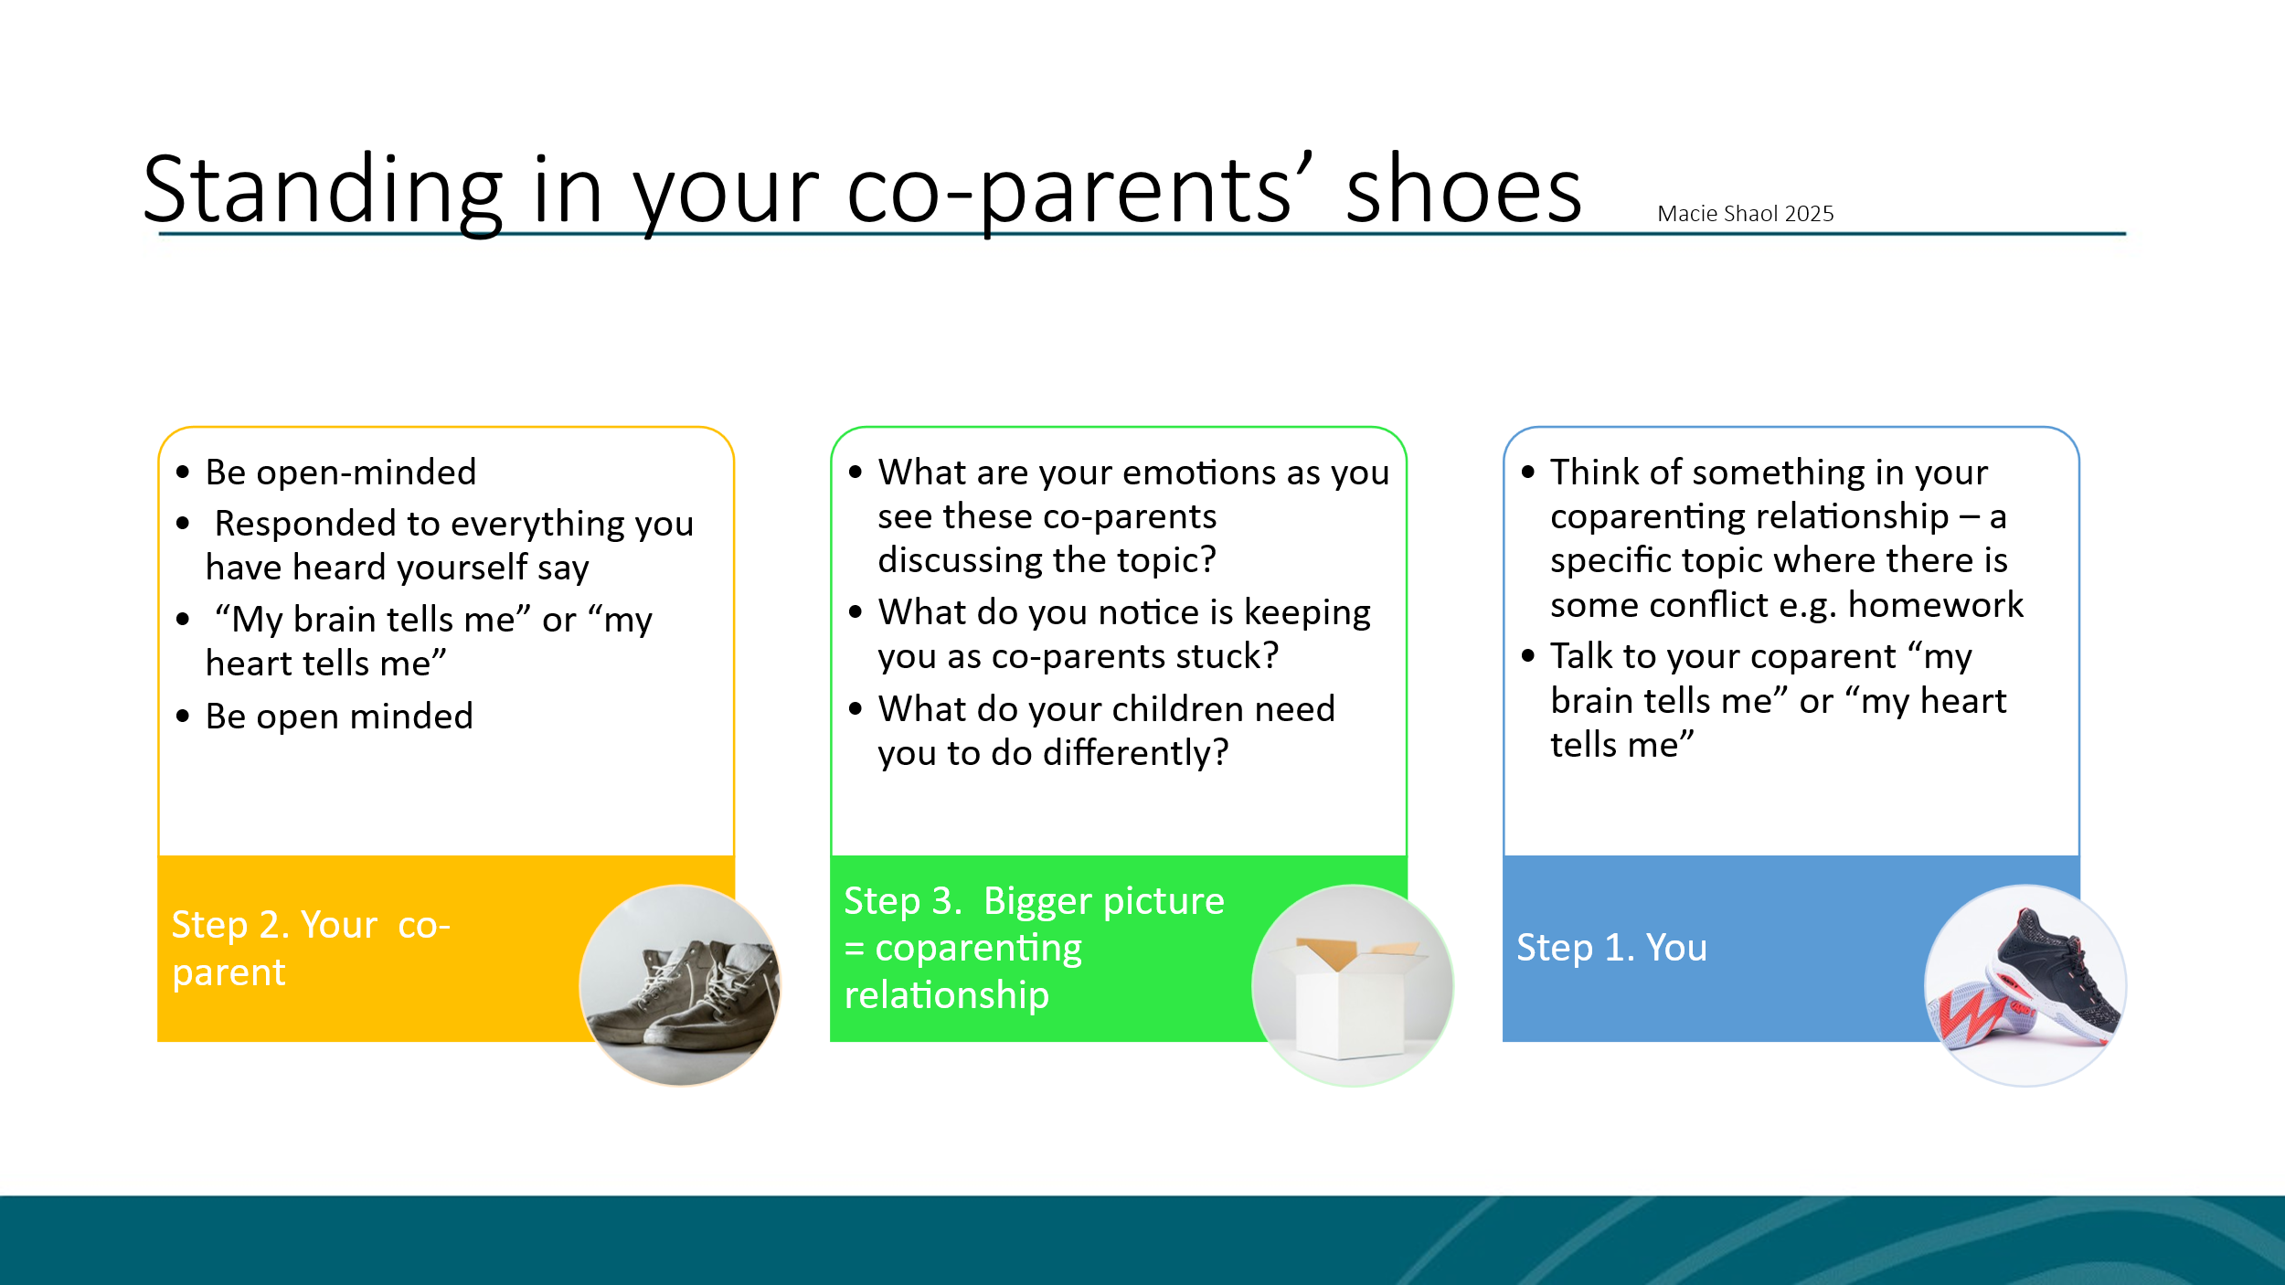

The exercise:
- Think of something in your co-parenting relationship that you and your co-parent are stuck on at the moment, a topic where there is some but not too much conflict. E.g. handovers, decisions about schooling, doing homework etc.
- Spend a moment thinking of the issue you want to resolve and perhaps write it down:

- Imagine 3 coloured circles on the floor: yellow, blue, green or use 3 chairs: yellow, blue, green.

- You = blue and imagine your co-parent standing opposite you.

- As YOU in the blue circle: Look at them and try to imagine they are there – now talk out loud about the topic you have written down using the phrases “my brain tells me” or “my heart tells me”.
This helps you see the situation from both an emotional and practical viewpoint. Tell your co-parents everything that you know about this topic. Do it respectfully and out loud.

NOTES:

- When you are finished, physically move to stand/sit in the yellow circle – be open-minded! You are now trying to see things from your co-parent’s perspective. YOU are now the CO-PARENT and now respond from your co-parents perspective to everything you have just heard yourself say. Use “My brain tells me” or “my heart tells me” phrases again.

NOTE: This may be hard but keep going, be open to new information. Remember, they are not really there… and you will know when it is time to finish.

- Keep moving back-and-forth between the blue and yellow until the topic is finished.

- Finally, stand or sit in the green area – this is the “bigger picture” or “the co-parent relationship” – this “bigger picture” knows everything about the relationship between you and your co-parent and deeply cares about you both. It cares that the coparent relationship works for both of you as well as your children. It might help if you imagine yourself rising up and looking down on both co-parents and using this to see the situation.

- Then, as the neutral co-parenting relationship, try to answer the following questions:
  - What are your emotions as you see these co-parents discussing the topic?

  - What do you notice is keeping you as co-parents stuck?

  - What do your children need you to do differently?

- Finally, answer the following questions:
  - Does anything feel different after this exercise?

  - What might your children need you to do differently in this situation?

  - What one practical action can you take, and when will you do it?

