Sheet 5: Managing emotions and coping post-separation
Separation is an emotional rollercoaster as you and your children navigate feelings of grief and loss of what was, anger, depression and relief as you start to move on and create a new life for yourself and your children.
However, learning to manage our emotions as parents helps us to create a stable and supportive environment for our children, helping them cope with the changes and hopefully reducing coparenting conflict.
Learning how you can increase time in your green zone is key to helping you reduce conflict with your ex-partner.
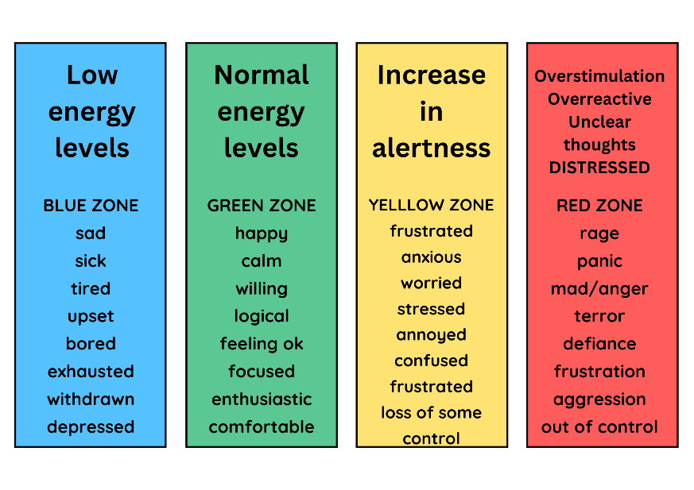

- What one positive change would help you get back and stay in the ‘Green zone’ emotionally for longer?
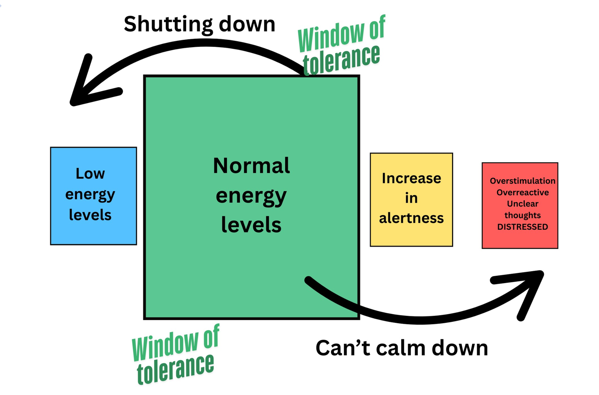

- What could you do to look after yourself in the short, medium and long term? And when are you going to do it?

The effect of separation on parents
- Depression: feeling sad and upset that the relationship is ended
- Guilt: many parents feel guilty about the decision to separate and worry about the impact on the children
- Anger: it is normal to feel angry response to the separation – at times it can be intense and difficult to manage
- Relief: in addition to the negative emotions, there may be feelings of relief and hope – especially if the relationship has been conflict and unhappy. It may be an opportunity to put difficulties behind you and start again.
Learning to cope
Your ability to cope is crucial to your child’s well-being. There are lots of simple things you can do to improve how you personally cope, including:
- Give yourself permission to put yourself first – taking time for yourself is not selfish.
- Be kind to yourself – sometimes we are much harder on ourselves narrowing thoughts than we would be to anyone else we speak to.
- Practice self-care and relaxation: parents under stress often stop eating well, exercising, or doing things they enjoy. This can cause even greater stress. This is the time that you really need to look after yourself e.g.
  - The well, exercise and get a good night sleep
  - Have times of relaxation
  - Do things you enjoy – the more refreshed you are, the more available you are to help your children.
- Give yourself time
  - Remember that coping with separation is a long process and it can be cyclical
  - There will be bad times when you feel low or upset, but remember that these will pass and things will get easier as time goes by
- Get the right kind of support
  - Don’t go through this alone
  - Find friends and family members who you feel can support you – don’t forget that they may be also going through upset when a relationship breaks down so may bias
  - Try and find people who have some distance from the situation and who can give you a more balanced view
  - At this point, you may find counselling helpful
- Begin the healing process
  - Frequently, the hardest thing to do is forgive yourself or your former partner and move on
  - Make a decision to start the healing process for yourself
  - The sooner you can accept what is happened and let go of hurt and upset, the sooner you can begin to move on and be there for your children

